HOSPITAL CLAIMS
1. Overall Process Flow
- Pull the claim in CAS/MPC.
- Identify the ManCalc edit.
- Open the claim image and Mentor document.
- Match the claim details against the claim image.
- Review the current and historical PIN codes.
- Validate the procedure, payee, and provider Tax ID.
- Follow the ManCalc Mentor decision steps.
- Review shared-savings eligibility.
- Determine whether shared savings applies.
- Open the contract-pricing application and evaluate the contract tree structures.
- Match the DRG and revenue codes against the contract tables.
- Review the applicable contract notepad from CIS.
- Identify the reimbursement method and percentage.
- Open CISPro and review the claim.
- Identify and research the CISPro CIS pend code.
- Follow the PPS Code Edit instructions.
- Update the SIS ID and reprice the claim.
- Obtain the Medicare-priced amount from CISPro.
- Apply the contract percentage to determine the final allowable.
- Enter the manual allowable in CAS using the applicable override.
- Bypass the resulting edit through the EI screen.
- Confirm whether the ManCalc edit is resolved.
- If the allowable exceeds the processor’s dollar limit, stop processing in CAS and pend the claim for high-dollar review.
- If the allowable is within the processor’s limit, verify “Pay Okay” and finalize the claim using MPP.
2. Screen / command map
Screen / Command | Purpose
Maccess | Pull claims from the team's work queue.
MPC | Main claim editing/finalization screen; shows provider, member, claim history/details and edits.
MHI | Used to enter MPC / recreate control lines, per transcript.
MPCS | Saves the CAS screen before moving to another screen.
CISPro | Obtain Medicare pricing and resolve pricing CIS pends
EHub | Claim image and member/provider information, including state and tax ID.
EBI Screen | Edit-bypass screen
PPS Code Edit Spreadsheet | CIS pend code reference
ATTPHY / ADDPHY / VN / T / RCDT | CAS fields used for specific mentor checks.

3. Screen-wise steps
Step No | Step Action | Screenshot | Expected Result / Additional Information | Comments / Decision
1 | Pull assigned claim in CAS/MPC, verify work status, review edit displayed on claim. | 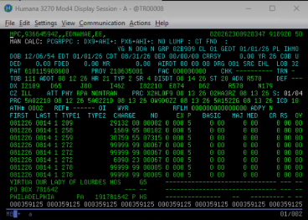 | ManCalc actionable edit visible. Indicates manual calculation required because contract provisions cannot be fully automated through CAS. | Confirm claim is ready for processing.
2 | Open claim image, applicable Mentor document, and pricing references. | 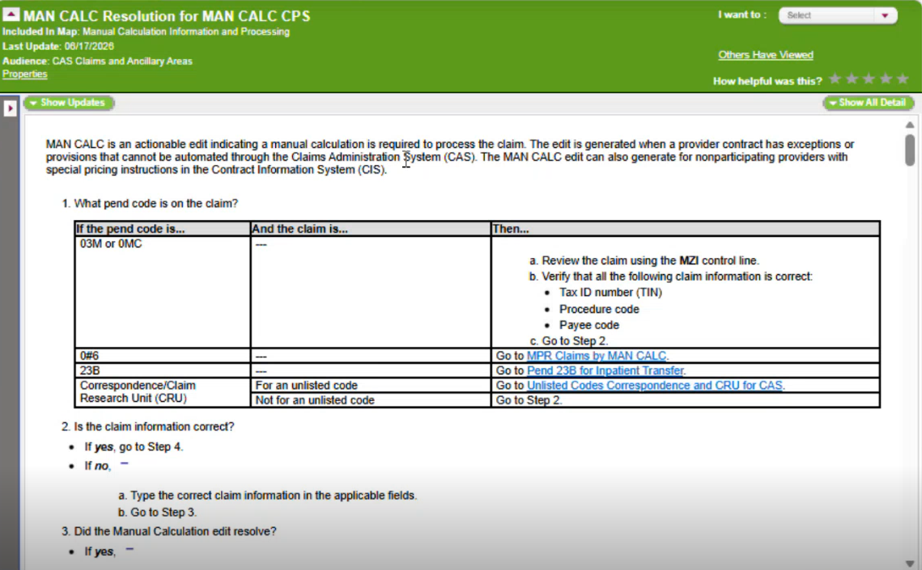 | Processors can compare claim data with source document and follow correct ManCalc path. | Gather all supporting documents before review.
3 | Match claim information between CAS and claim image (TOB, diagnosis, DOS, revenue codes, procedures, provider/payee). | 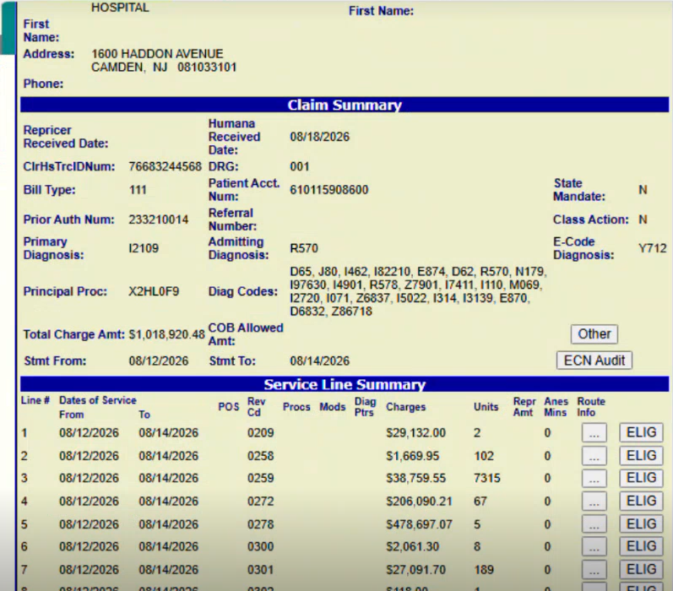 | If mismatch exists, investigate before proceeding. | Scenario: TOB 111, Dx I2109, DOS, Revenue Code 0209 matched.
4 | Access MHI/MHN Claim Information screen, review PIN. | 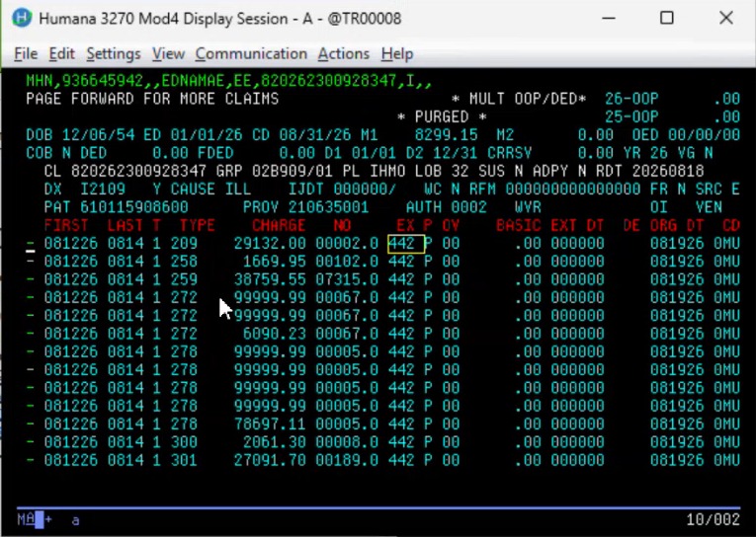 | Review all pages if claim spans MHN screens. | Current PIN displayed: 442. MHI = single page, MHN = multiple pages.
5 | Review historical PIN codes by using I modifier and selection code "S". | 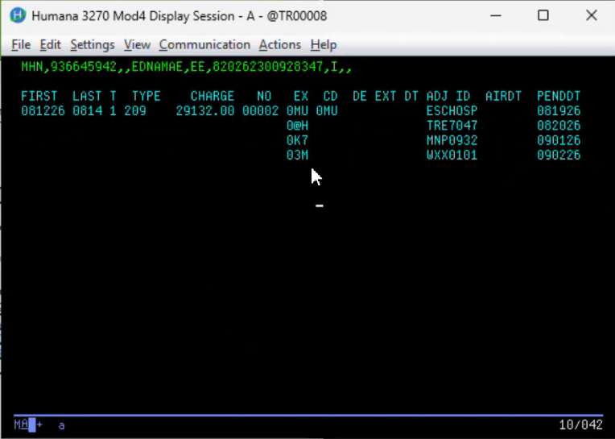 | Use PIN dictated by Mentor logic. | Historical PINs include 03M, 0K7, etc. Applicable historical PIN identified as 03M.
6 | Validate procedure details, payee information, and provider Tax ID using MCI/MHI screen. | 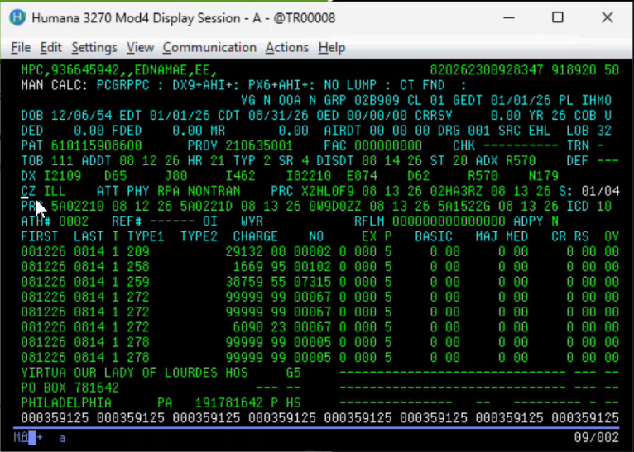 | Tax ID should match claim image. Return to MPC using MPCR. | Investigate discrepancies before pricing.
7 | Continue through ManCalc Mentor decision sequence. |  | .
8 | Check whether claim meets specified LOB and State criteria (including LOB 93 Florida). | 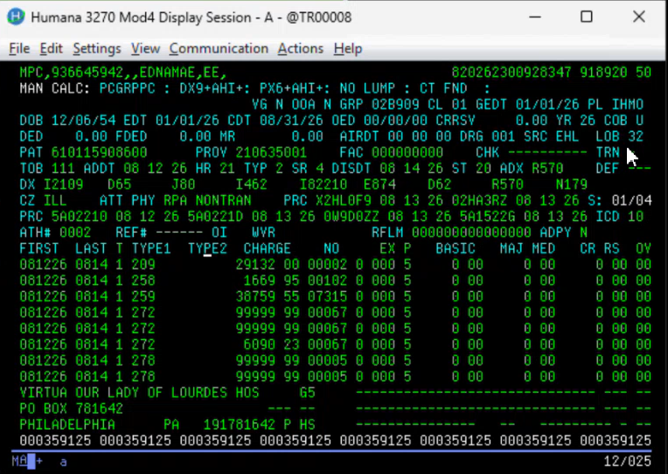 | Claim did not meet specified condition.  Select No and continue.
9 | Verify whether facility claim is billed with Modifier 50. | 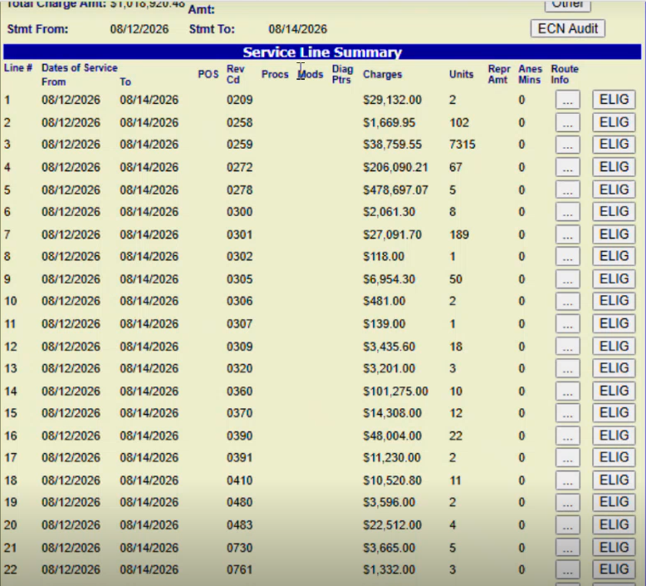 | Facility claim identified but Modifier 50 not present. | Select No and proceed.
10 | Check for endoscopic CPT/HCPCS codes using Mentor-linked spreadsheet. |  | No valid endoscopic code present. | Select No and continue.
11 | Check for HCPCS K0553 or K0554. |  | No CPT/HCPCS code billed. | Select No and proceed.
12 | Check for HCPCS codes beginning with J, Q, or S. |  | No applicable HCPCS code present. | Select No and continue to Shared Savings review.
13 | Review Shared Savings Eligibility Exceptions and provider participation status. | 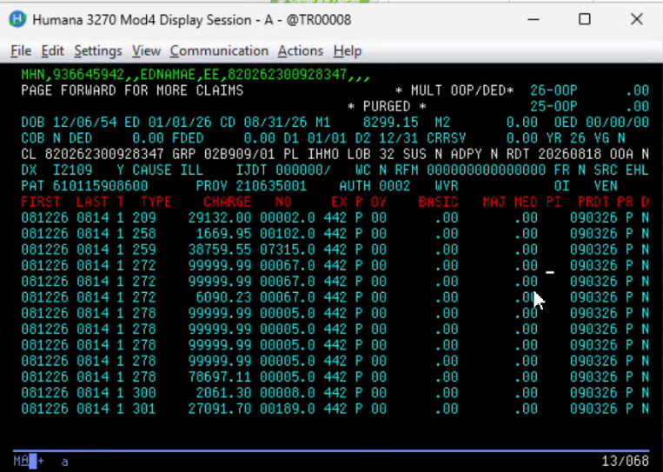 | Provider indicator = P (Participating/In-Network). Shared Savings not applicable. | Continue standard processing.
14 | Confirm Shared Savings Eligibility. |  | Claim not eligible because provider is participating. | Select No and proceed to contract review.
15 | Open Contract in CIS, using the CIS ID and the CIS Calculation Overview document | 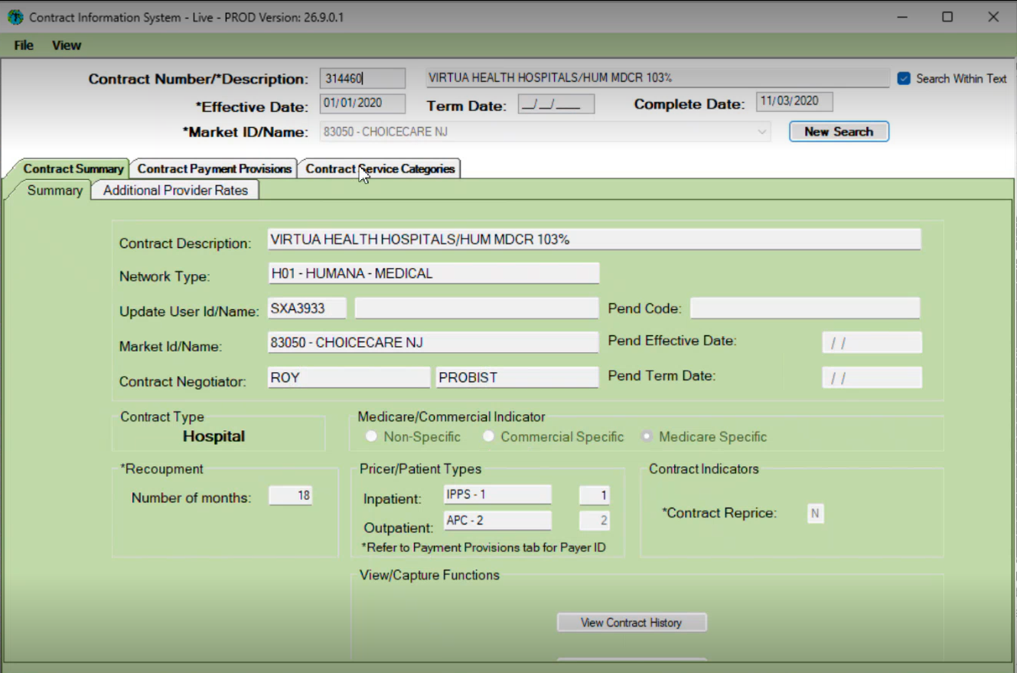 | Contract displayed as multiple tree structures (100-300+ possible). | Evaluate structures sequentially until match found.
16 | Evaluate first contract tree structure by validating DRG. | 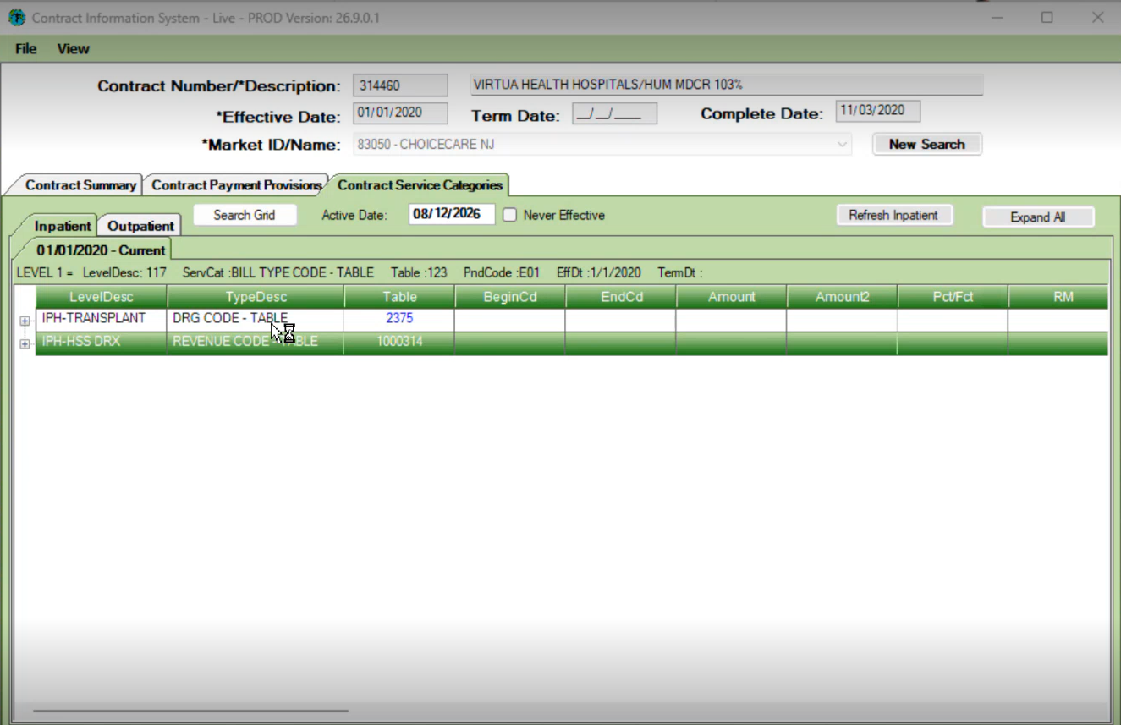 | DRG 001 found in Table 2375. | Continue within same tree structure.
17 | Validate Revenue Code condition in same tree structure. | 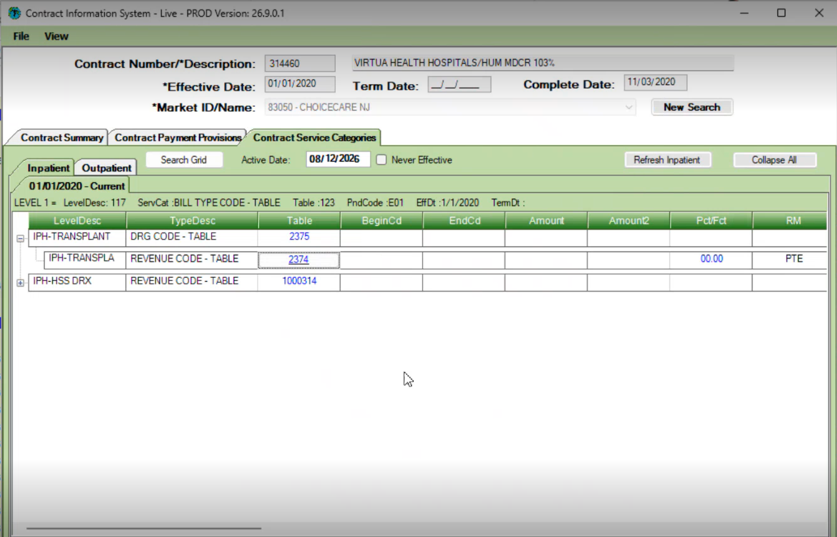 | Revenue Code 0209 found in Table 2374. | Continue to reimbursement section.
18 | Review reimbursement percentage and contract notepad. | 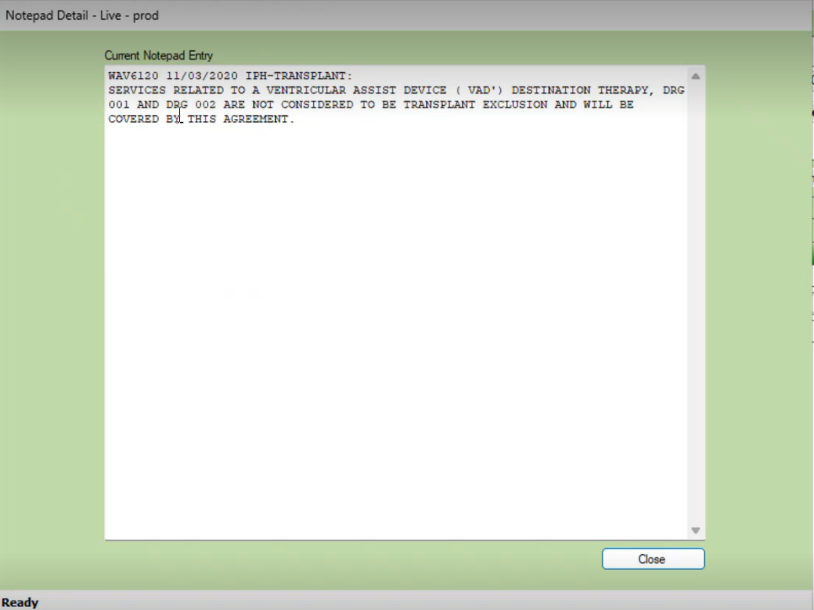 | Structure showed 0.00 allowable. Notepad indicated DRG 001/002 VAD services covered and not transplant exclusions. | Structure not final pricing path. Move to next structure.
19 | Evaluate next contract tree structure (Revenue Code + DRG checks). | 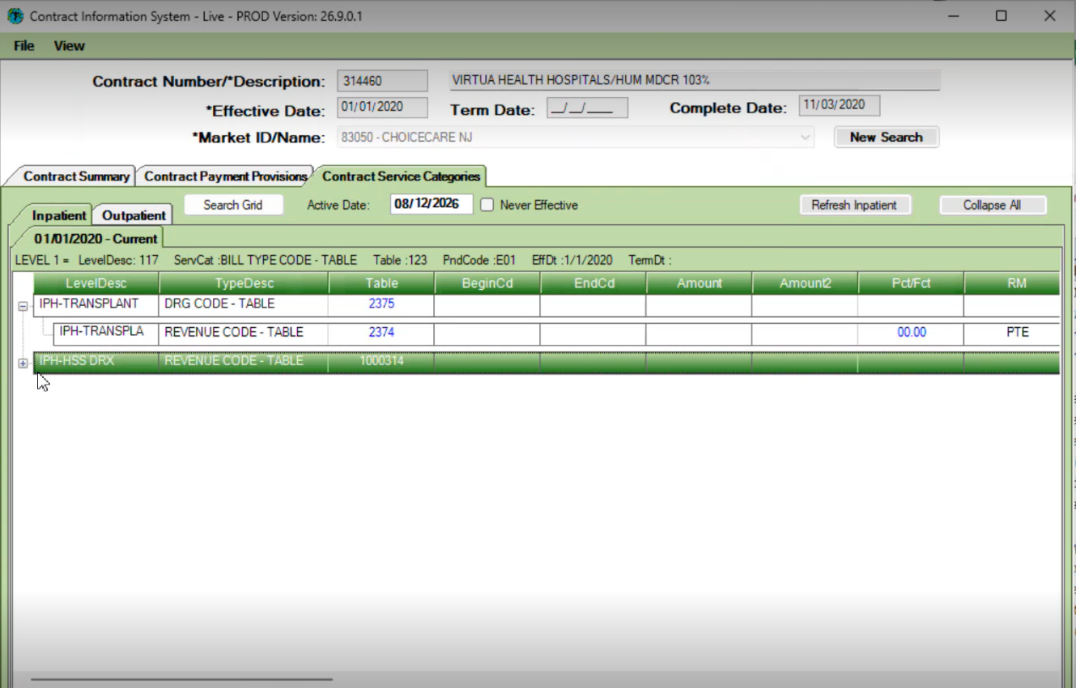 | Revenue Code 0209 and DRG 001 matched. Reimbursement Method = DRX, Percentage = 103%. Hence should be validated with CISPro | Applicable contract provision identified.
20 | Open CISPro and search using claim number. | 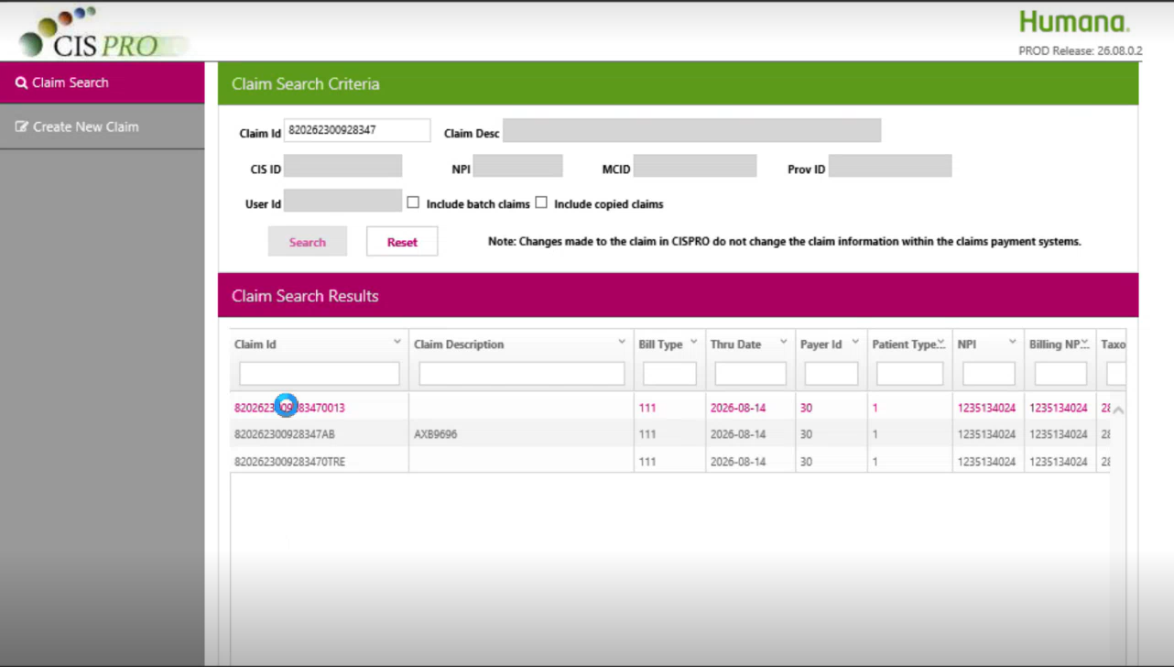 | Three records returned; top record selected. | Open claim for pricing review.
21 | Review CISPro CIS pend or pricing errors. | 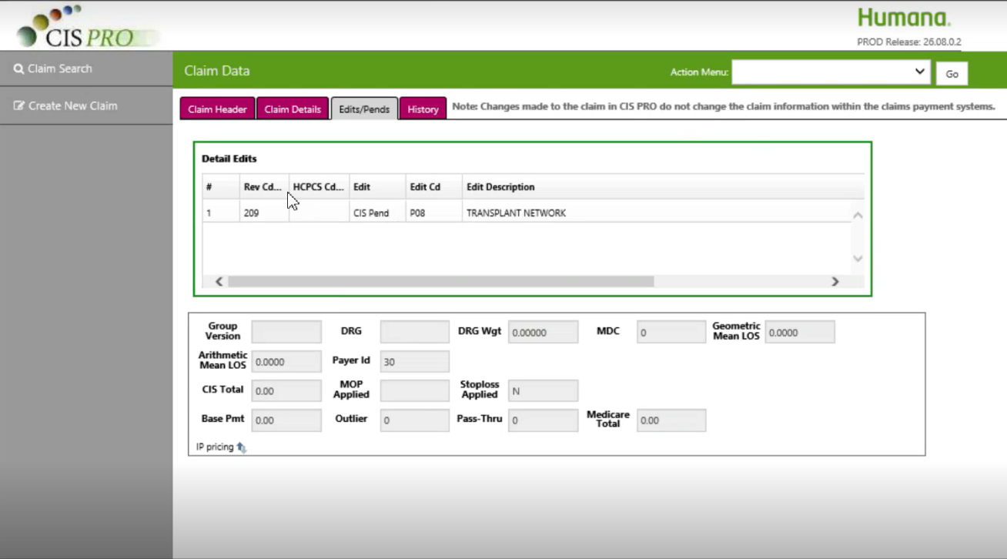 | CIS Pend Code P08 displayed. | Research P08 before proceeding.
22 | Open PPS Code Edit Spreadsheet from Mentor and locate P08 instructions. | 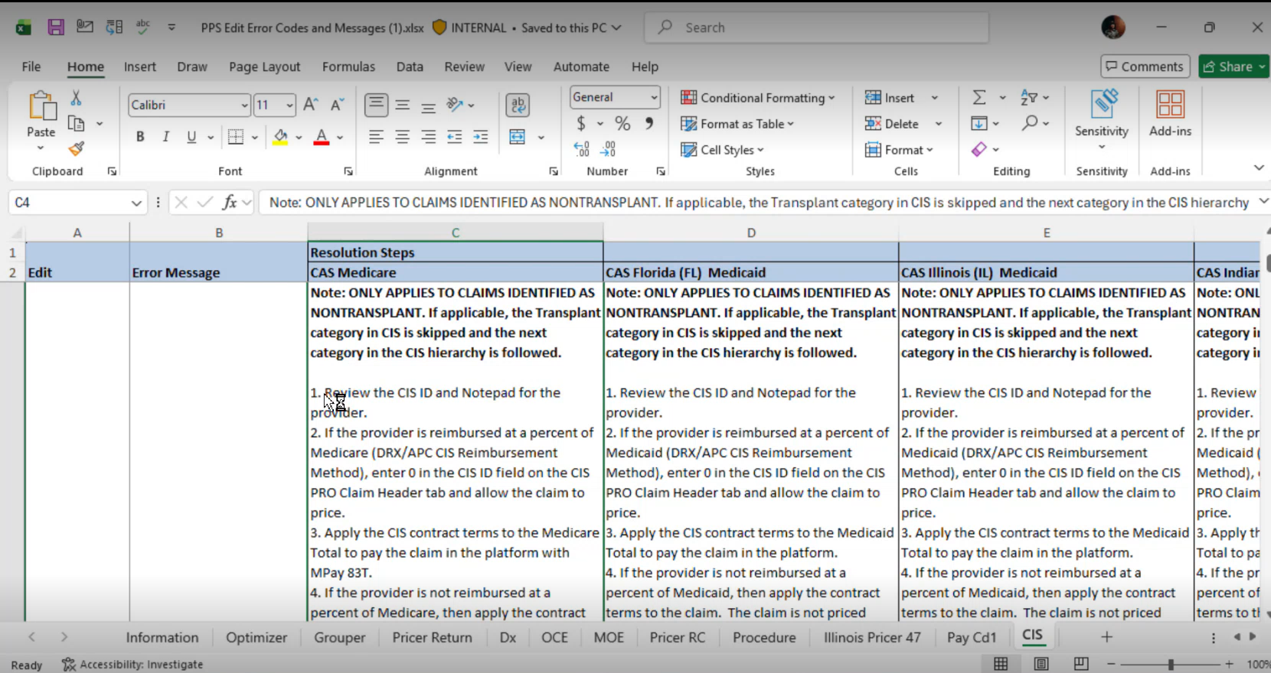 | P08 = Transplant Network. LOB 32 Medicare, CAS platform, Column C instructions applicable. | Follow applicable PPS guidance.
23 | Determine whether claim is transplant-related. |  | Contract notepad confirmed DRG 001 is not a transplant exclusion. | Follow non-transplant processing instructions.
24 | Verify CIS ID and provider information. | 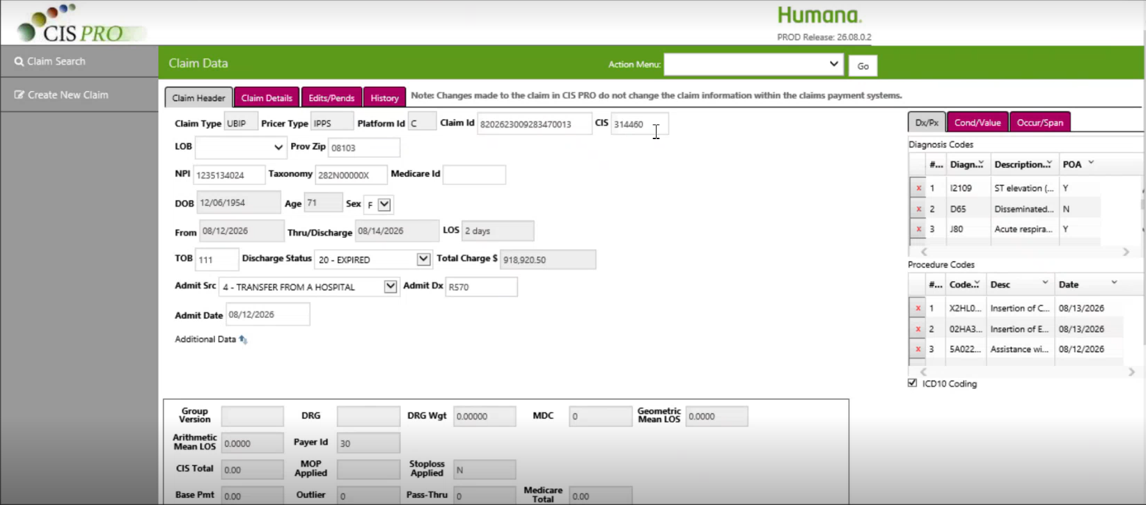 | SIS ID = 314460 and matched in CIS Pro. | Validate provider identifiers and claim details.
25 | Review CISPro tabs (Header, Detail, CIS Pend/PINs, History). |  | Provides claim, pricing, suspend, and historical activity information. | Confirm pricing status before adjustment.
26 | Update CIS ID to 0 and Sava & Price claim. | 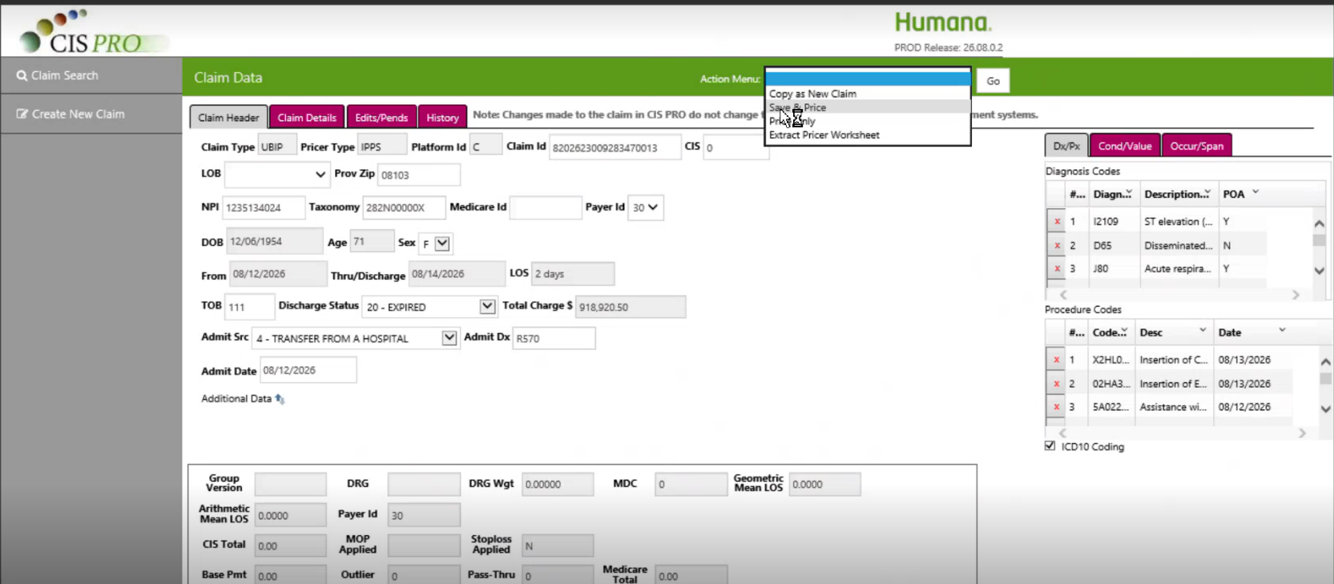 | Applicable because reimbursement method = DRX at 103% of Medicare. Save and Price executed. | Repricing should resolve P08.
27 | Enter change reason/comment and save. | 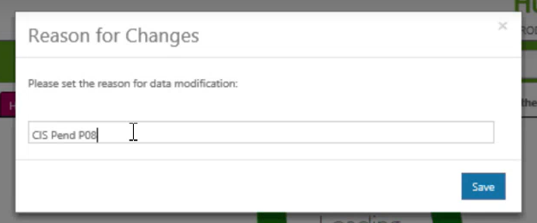 | Reason entered: P08. CIS Pend resolved and tabs reduced from four to three. | Confirms successful resolution.
28 | Obtain Medicare-priced amount from CISPro after repricing. | 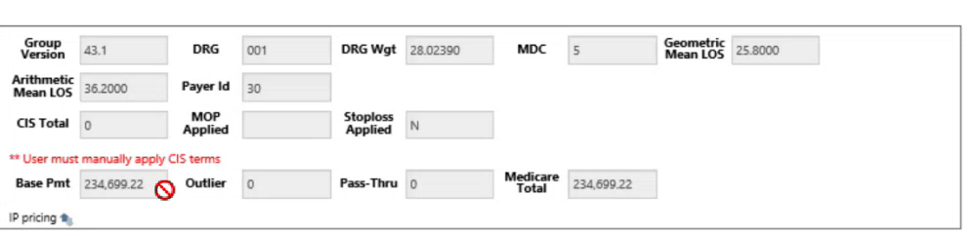 | Medicare base amount available for manual calculation. | Capture actual amount from system.
29 | Calculate final contract allowable. | 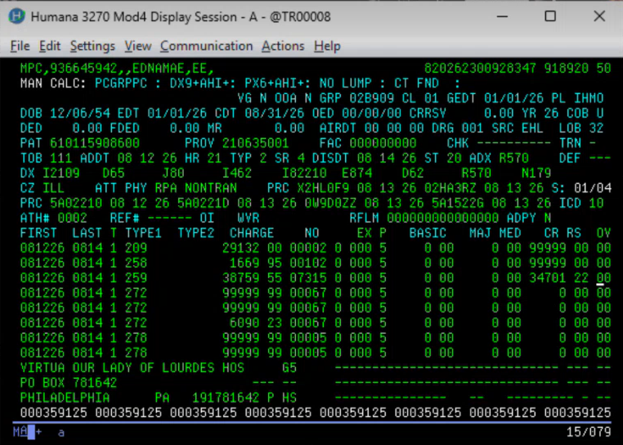 | Medicare-Priced 234,699 | Verify final allowable using actual calculation.
30 | Apply manual override in CAS using calculated allowable. | 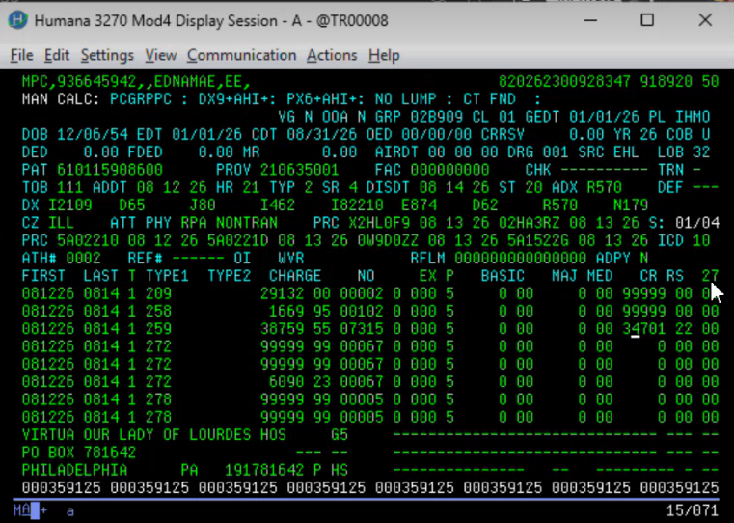 | Override 27 used. Allowable pushed to facility claim as whole-claim adjustment. | Required because DRX/APC pricing cannot auto-calculate in CAS.
31 | Bypass generated edit using EBI screen. | 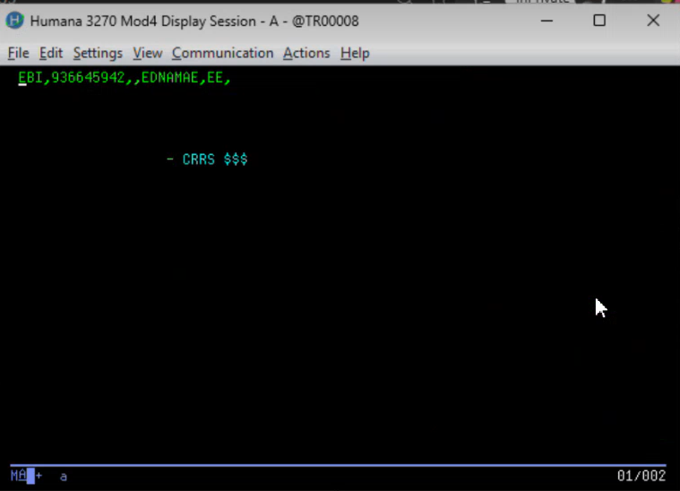 | Enter X against applicable edit and return to MPC. | Manual-pricing edit bypassed as permitted.
32 | Enter MP Code and Payee information. | 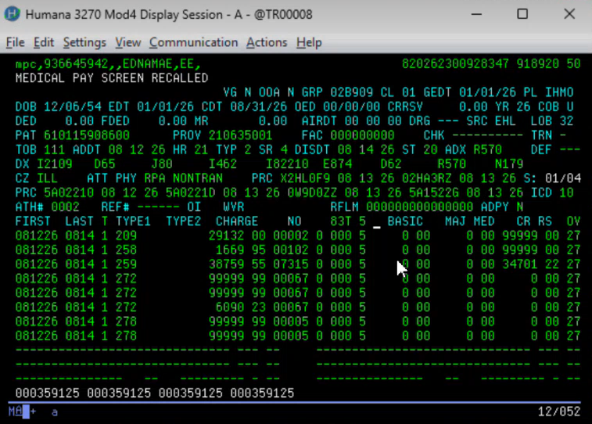 | MP Code = 83T; Facility Payee Code = 5. | ManCalc edit resolved.
33 | Check for SCRMX (Screen Max) edit. | 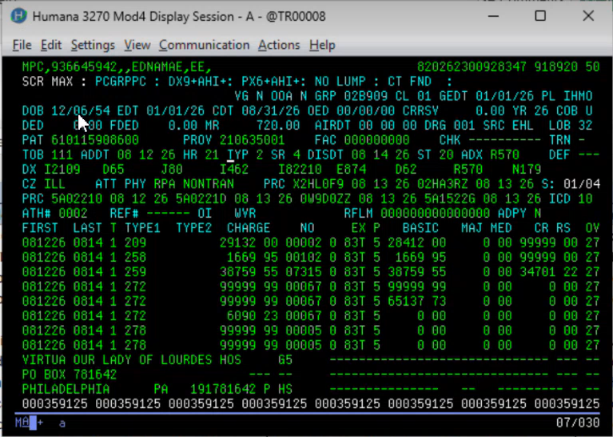 | SCRMX indicates allowable exceeds processor authority limit. | If SCRMX appears, processor cannot finalize claim.
34A | High-Dollar Exception Path (if SCRMX generated). |  | Claim routed via Maccess to authorized reviewer/high-dollar queue. | Actual scenario outcome. Second-level review required.
34B | Within-Authority Processing Path (if SCRMX not generated). | 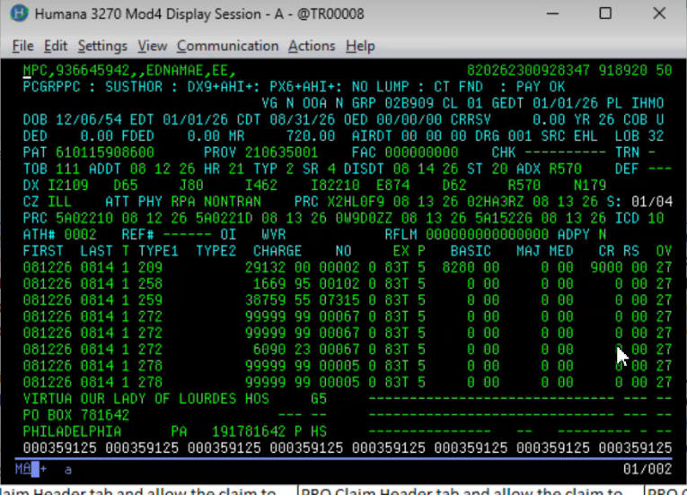 | Pay Okay displayed. Enter MPP and finalize claim payment. | Used only when amount is within processor authority.

